Unit Title: Phases of the Moon Grade: 6
Content Standards:
The student will be able to:
- Describe changes in the appearance of the moon during a month.
- Identify the pattern of change (phases) in the moon’s appearance.

Language Objectives:
The student will be able to:
- Read aloud with a partner
- Summarize reading and illustrate key events in reading
- Write a paragraph explanation of the moon phases including a main idea and supporting details.

Key Vocabulary: phases, waxing, waning, crescent, gibbous, new moon, full moon, half moon

Connections to Prior Knowledge/Building Background:
Rotation
Revolution
Axis

Visuals/Resources/Supplementary Materials:
- Styrofoam ball painted half black
- Dowel
- Plastic spoons
- Paper plates,
- Penny and quarter
- Pictures of the sun and earth
- Post its
- Moon phase labels

SIOP features
Preparation:  Links to background  Links to past learning  Strategies incorporated | Integration of processes:  Reading  Writing  Speaking  Listening | Scaffolding  Modeling  Guided practice  Independent practice
Application:  Hands on  Meaningful  Linked to objectives  Promotes engagement | Grouping Options  Whole class  Small groups  Partners  Independent | Assessment:  Individual  Group  Written  Oral

Meaningful Activities:
Read aloud The Girl Who Married the Moon
Anticipation Guide
Expository Text and Reading Comprehension Guide
Coin Activity showing quarter and penny in comparison to earth and moon
Styrofoam ball hands-on moon phase exploration
Moon phases flip book
Moon phases diagram
Create group poster representing the relationship between the sun, earth, and the moon in its phases.

Meaningful Language Activities:
Listen to Read aloud
Partner read information about moon phases
Complete graphic organizer of key events with illustrations
Write sentences color coded for main idea and supporting details
Compile sentences into a paragraph using transition words

Unit Sequence:
DAY ONE:
- Students will individually fill out anticipation guides.
- Read the guide together and make a tall chart of answers.
- Tell the students this is called an anticipation guide and ask if they have an idea why we did this activity. Help students draw conclusion that we are accessing our background knowledge to make connections with our new thinking as we begin learning about the moon for the next week.
- State and explain objectives.
- Review previous knowledge of the verbs rotate and revolve. Apply same knowledge to nouns rotation and revolution. Have students stand and rotate at their desks. Partner share—describe rotation to a partner. Call on one pair to share their description of rotation. Next review the term axis. Show visual model of our globe with axis through the middle. This illustrates rotating on an axis. Then have students revolve around their tables. Again partner share a description of the action of revolving. Finally have the students compare revolution and rotation with a partner. One partnership shares their comparison. Add comparisons and descriptions to the anchor chart to keep on display for the duration of the unit.
- Class will do coin activity to demonstrate that the same side of the moon is always facing the Earth. Have students predict how many rotations the penny will do prior to the activity.
- Regroup class following activity and discuss inferences made. Add information to anchor chart.

DAY TWO:
- Read Aloud “The Girl Who Married the Moon”
- Follow lesson plan for Read Aloud and Moon Phase diagram.
- Use smart board lesson to increase engagement and involvement. Students will move the moon phases and labels to the correct position in relation to the sun and the earth.
- When completed, students will create an individual copy of the phases of the moon illustration.

DAY THREE:
- Partner Read expository text using a reading comprehension guide.
- Teacher reads aloud first two paragraphs and models procedure to adding visuals to moon fact sheet for the first two squares. Students also illustrate on their own paper. Teacher takes suggestions for next two squares. Put sticky note on statements about moon phases.
- Have two students model partner reading. Students sit side by side facing in opposite directions. (Shoulder to shoulder). Speak in a voice that can only be heard by their partner. Read alternating paragraphs. After each paragraph the listening partner will make a statement about the paragraph just completed before he/she begins reading. This can be a quick summary or question. Students will partner read the section and add visuals to the rest of their moon fact sheet.
- Create Moon Phases Flip Book for practice and reference.
- Cut apart the phases of the moon and place them in the correct order. Mix them up and put them in the correct order again.
DAY FOUR:
- Styrofoam Moon Demonstration
- Model and write Moon Paragraphs
DAY FIVE:
- Create Moon Diagram
- Create Group Poster illustrating the Earth, sun and moon relationship.
Anticipation Guides

Purpose: to stimulate student interest in a topic and activate background knowledge before a lesson; to clarify main ideas and bring closure when used again at the end of a lesson

Method:
1. Give each student a copy of the guide and have them mark whether they agree or disagree with each statement. This can be done individually, with partners, or in small groups.
2. Discuss the anticipation guide responses as a whole class allowing students to defend their choices.
3. Read the text or conduct the lesson.
4. Have students mark and discuss statements again at the end of the lesson.
*Students will often mention the guide in the course of the lesson as information comes up that proves or disproves each statement.

________________________________________________________________

Anticipation Guide Name ______________________________

The Moon Date _________________Class __________

AGREE DISAGREE

_____ The moon changes shape. ____
_____ The moon produces light. ____
_____ We always see the same side of the moon. ____
_____ A moon “day” and a moon “year” take the same amount of time. ____
_____ The moon revolves around Earth once a year. ____
_____ Waxing means getting smaller. ____
_____ Waning means getting larger. ____

COIN ACTIVITY

Using visual aids to represent the moon and the earth, students will be able to see that the same side of the moon is always facing the earth.
Materials needed: one quarter (or nickel) and one penny per pair of students.

Possible Inferences and Background:
The moon rotates on its axis every 27.3 days which is almost the same amount of time it takes to revolve around Earth. Because these happen at the same rate, the same side of the moon is always facing the Earth. One rotation or day and one revolution or year are the same length on the moon. Because we always see the same side of the moon, it doesn’t appear that it is rotating.

Process:
- Have students predict how many times the penny will rotate during its revolution around the quarter.
- Students place the quarter on the table to represent Earth.
- Explain that the penny will represent the moon. Since the same side of the moon always faces Earth, have students place the penny with Lincoln facing the quarter “earth” while it revolves around it.
- Explain that the Earth “quarter” would rotate about 28 times during this demonstration, indicating night and day. However we will not be rotating the quarter, rather we will focus on the moon’s rotation and revolution.
- Students will rotate and revolve the penny while making sure Lincoln is always facing the quarter. Have them count how many times Lincoln rotates during one revolution. Using manipulatives students will see that it rotates only once during a revolution. If the penny must always face the quarter (moon always face the earth) it only rotates once during the revolution)
- Ask students what they were able to infer based on the activity.

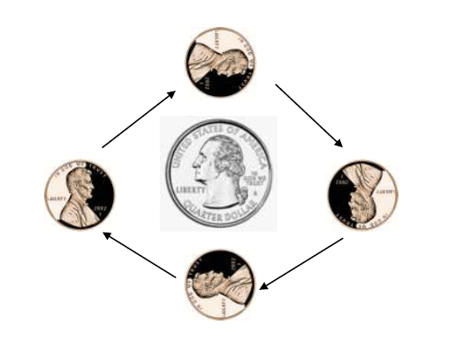

READ ALOUD AND MOON PHASE DIAGRAM

STANDARD: Students will understand that the appearance of the Moon changes in a predictable cycle as it orbits Earth and as Earth rotates on its axis
Content Objective: Given pictures of the Moon phases, sixth grade students will correctly place the phases of the moon in the correct location in regards to the Sun and the Earth with all 8 correct.
Language Objective: SWBAT listen to a Native North American story.
SWBAT write three to five questions and/or connections about the story to what they know about the moon.

Procedure:
Engage 15 minutes
First, we are going to listen to a tale from Native North America (Indians) about the mystical thing called the Moon. It is called, 'The Girl Who Married the Moon' (11:21). The story is eleven minutes long and so http://youtu.be/oFBQPlREkMc
I am going to pause the every two minutes and I want you write a question that you have about the reading on your worksheet or connect the story to occurrences of the real moon. By the end, you should have three to five questions or statements about the story.
Long ago there were two girl cousins who lived in a large tribal village. Those evenings when the moon was out, they liked to go to the beach and play. Claiming the moon as their husband, they spend the night gazing and making love to the man in the moon.
For shelter they had propped up a bidarka (large skin boat), and during the night they changed positions several times, so they could always face the moon. In the morning, upon returning home, their parents always questioned them about their whereabouts. The girls told them how they had watched the moon until it passed from sight. Many of their family heard them tell how much they loved the moon, always wishing they were moons.
One evening, with other young people of their tribe, they amused themselves on the beach. Night came and the others returned to their homes, but the two girls remained. When the moon went away out of their sight, one complained, "Why does the moon hide so suddenly? I like to play with him and enjoy his moonlight." "I, too," said the other. It was not yet midnight, and the moon was already behind the clouds.
Up to now they had not noticed how disheveled their appearance was from playing. They became startled when they heard the voice of a young man as he approached them. "You have been professing your love for me," he said. "I have observed you and know you love me, therefore, I have come for you. But since my work is very hard, I can only take one of you--the more patient one."
Each begged to be chosen. He said, "I have decided to take both of you. Now close your eyes and keep them closed." So he grabbed each by the hair, and the next moment they were rushing through the air. The patience of one wore thin. As she opened her eyes, she felt herself drop down, down, down, leaving her hair behind in his hands. She found herself beside the bidarka where she had left it.
The patient cousin kept her eyes closed the entire time, and in the morning found herself in a comfortable barrabara, the home of the moon. There she lived as the wife of the moon, happy in loving him. Generally he slept during the day, as he worked all night.
Frequently he went away in the morning and returned in the evening. Sometimes he was gone from mid-day until midnight. His irregular schedule puzzled his wife. But he never offered an explanation to her of what he did in his absence.
His silence and indifference piqued the young bride. She waited as long as she could, until one day she said, "You go out every day, every evening, every night, and you never tell me what you do. What kinds of people do you associate with, while I am left behind?"
"I am not with other people, for there are not my kind of people here," he said. "I have important work to do, and I cannot be with you all the time."
"If your work is so hard, can you take me with you to help you sometimes?" she asked.
"My work is too hard for you," he replied. "I brought you up here, because I had no rest when you were down there. You and your lovely cousin were constantly staring at me and teasing me. Now stop your foolishness, you cannot help me. Stay home and be happy for me when I do return."
"Surely, you don't expect me to stay home all the time." She began to weep. "If I cannot go with you, can I go out by myself occasionally?"
"Of course, go anywhere you like, except in the two homes you see yonder. In the corner of each there is a curtain, under which you must never look." After this warning, he left his barrabara, and that night he looked paler than usual.
Later, she went out for a walk. Although she went far and in different directions, she saw no people. She tried several short trails, and on each saw a man lying face down. It gave her pleasure to kick them to disturb them. Each would turn and look at her with his one bright, sparkling eye and cry out, "Why do that to me? I am working and busy." She kicked all of them until she tired and ran home.
On her way she saw the two forbidden barrabaras, and she just had to look inside. A curtain hid a corner in the first. She couldn't resist the desire to look under the curtain. There she beheld a half-moon, a quarter-moon, and a small piece of moon. In the second barrabara, she found a full moon, one almost full, and another more than half-full.
Thinking about the beautiful pieces, she decided it would be such fun and no harm to try on one to see how she would feel. The one almost full pleased her most, so she placed it on one side of her face and there it stuck. She cried, "Ai, Ai, Y-a-h, Ai, Ai, Yah!" She tugged and pulled but the moon would not come off. For fear her husband would soon arrive, she hastened home, threw herself on the bed, and covered that side of her face.
There he found her, complaining that her face pained her. He suspected the real cause and went out to investigate. Upon his return he asked her about the missing moon. "Yes," she admitted. "I tried it on for fun, and now I cannot take it off." He laughed and laughed at her. Gently he pulled it off for her.
Seeing his good humor, she told him of her eventful day, especially the sport she had with the one-eyed people scattered about the sky.
"They are stars," he said reprovingly. "Since of your own free will you put on this moon, you can wear it from now on and help me in my hard work. I will finish my rounds with the full moon, and after that you can start in and finish out the month while I rest."
To this happy arrangement she consented gladly. Since that time the two have shared the hard work between them--the man in the moon and his lady in the moon.

New Information (I Do) 10 minutes
Over a month you can observe the Moon's full range of appearances and it's pattern of movement in the sky. The phases of the Moon (new, crescent, quarter, gibbous, and full) are a result not in the change in the actual shape of the moon, but are result of the position of the Sun, Moon, and Earth. That is, the apparent changes in the Moon's shape are simply changes in the portion of the lit side of the Moon that you can see from Earth.

The Moon appears a little different every day or night, and then begins to repeat its changes of shape or phase each month. We call these 'the phases of the Moon' or the 'Lunar cycle' and there are five different shapes that occur within the month. These are full, crescent, gibbous, new, and quarter. The month is based on the changing Moon- that's why its called a “Moon-th”.
Removed Chinese New Year information: It only applied to this year’s class and making that connection.

Examples (We Do) 10 minutes
MAKE STORY CONNECTION TO NEW LEARNING:
Why do you think the Natives of North America had a tale about the Moon? (It was a mystery to them and they wanted to explain why it changed throughout the month)

How did we begin to understand about the phases of the moon.

Discuss questions students created on their post-it notes during the story. Add them to the “Want to Know” portion of the anchor chart. Refer back to the chart regularly to determine which questions our study of the moon each day has answered and add new questions as they arise.

Let's talk about the phases of the Moon. I am passing out a worksheet that shows the many changes that the Moon appears in a month. The phase depends on the position of the moon in relation to the Sun and the Earth. There are eight phases of the moon. The phases are named after how much of the moon we can see, and whether the amount we see is increasing, or decreasing each day. It takes our moon 29.5 days to completely cycle through all eight phases.

SMART BOARD LESSON DIAGRAM and MOON PHASE DESCRIPTIONS:
Discussion Questions:
Does the moon make light? (No. It reflects it)
Where is the light coming from? (The sun).
Does the sun go away at night? (No, it is just on the other side of the earth)
Now turn your attention to the Moon Cycle worksheet I have given you. Let's talk about the moon’s many phases.
Begin the smart board demonstration, have students follow along with their diagram.
During the new moon phase, the moon is between the sun and Earth. Because this placement means that the moon's illuminated half is facing away from Earth, the moon is not visible from Earth. As the Moon continues its orbit, the illuminated side gradually becomes visible and is seen as a crescent. Over the next few days, the crescent appears to grow, or wax, showing a larger portion of the illuminated side of the moon each successive day. When half of its illuminated hemisphere becomes visible from Earth, the Moon appears as a half-disk, also known as the "half moon." This is the first-quarter phase. From here it grows to full moon and then begins to shrink until we return to a new moon.
Students fill out their worksheets with the names of the different phases.
Independent work (You Do) 10 minutes
Students draw the phases of the moon around the Earth.
Closing Procedure: 2 minutes
Review the objective and assess whether we accomplished it today.
Assessment:
Each student will show me their lunar cycle worksheet and I can informally assess if they have completed the work.

Partner Reading with Reading Comprehension Guide—Moon Fact Sheet:
Content Standards:
The student will be able to:
- Read expository text regarding pattern of change (phases) in the moon’s appearance.
- Identify the pattern of change in the moon’s appearance. (Moon phase flip book)
Language Objectives:
The student will be able to:
- Read aloud with a partner
- Summarize reading and illustrate key events in reading

Before:
Pre-reading Activity
Review moon vocabulary (included at beginning of unit plan)
Display Moon Fact Sheet on Smart board.
Preview Moon Fact sheet questions for focused reading.
Have students take a “picture walk” through the reading section noting the headings, subheadings, charts, graphs, illustrations, and so on. As a whole class make a note of where answers to the comprehension guide are likely to be located. Write page numbers on the displayed copy of the Guide. Provide a reading comprehension guide for ELL students with page numbers already included to facilitate focused reading.
Teacher reads and students follow along for the first two paragraphs. (Information for the first “fact” is located in this section. Think aloud through the reading and model answering and illustrating the first box on the fact sheet. Model the first two squares—Information is found on the first page.
During:
Procedure for Partner Reading:
- Students sit with their chairs side by side but facing in opposite directions. (ear to ear)
- Students alternate reading aloud by paragraphs. You can individualize this for students with reading or language challenges if time becomes an element.
- The student who does not read must comment, make a connection, or ask a question about the paragraph read by his partner before beginning his reading.
- Students have a task for them to complete related to the reading (Moon Fact Sheet) while they are reading aloud. This allows for the difference in time that different partners will need to finish the reading.
After:
- Students compare and share moon fact sheets with reading partner, and one other pair. If another student has an idea or illustration that helps your understanding, add to your own illustration or information.

Assessment
Gather and analyze facts and illustrations for comprehension and further reteaching.

Moon Flip Book:
When students have completed the moon fact sheet, have them create their moon flip book for reference. Students cut along the dotted lines of each moon phase. Begin with the “Moon Phases Flip Book” section and place them in order according to the picture. Hold them on the right side of the book and flip through the images to view the changing phases.

Mix them up and place them in order again to practice the correct order. Refer to the diagram from Day Two to check your work.

Have your reading partner check your order.
Check students’ moon phase order
Students staple books in order for reference.
Moon Fact Sheet Name ____________________________
Expository Reading: Date ________________Pd.___________

The moon is Earth’s closest neighbor. It is 384,000 miles from Earth. | Traveling 100 km per hour, it would take 5 months to get to the moon.
The moon revolves around Earth. | Earth revolves around the sun.
The moon does not produce light. It reflects light from the sun. | The different shapes of the moon that you see in the sky are called phases.
Phases are caused by the changes in the position of the sun, moon, and Earth. | The phase of the moon depends on how much of the sunlit side of the moon faces Earth.
Include a fact that you found interesting from the reading in this section. | Include a fact that you found interesting from the reading in this section.

STYROFOAM MOON and MOON PARAGRAPHS
Content Standard:
SWBAT
- Describe changes in the appearance of the moon during a month.
- Identify the pattern of change (phases) in the moon’s appearance.

Language Standard:
SWBAT
- Listen to song.
- Read lyrics while song is played.
- Write a paragraph explanation of the moon phases including a main idea and supporting details.

This is a demonstration that shows the appearance of each phase of the moon. It also shows that the phase that we see depends on the location of the sun, moon, and Earth to each other. To keep the demonstration simple, we do not have the Earth rotate or revolve or have the moon rotate. This can be discussed with students as well as the scale of the sun, moon, and Earth.

Materials needed: Computer, projector, Large Styrofoam ball painted half black on a stick, large sun and Earth, labels for the moon phases, pictures of the moon phases, scaffolded paragraph

Engage: Play the moon phases song. Provide each student with a copy of the lyrics to follow along. Copy of lyrics will include illustrations of each phase for ELL and Special needs students.
http://youtu.be/HkvlrWpsnuQ

Review: Refer to quarter/penny activity when the moon always faced the earth. We will be creating a “human version” of this illustration with each of the eight phases (each phase lasts approximately 3.5 days). View animated moon diagram located at http://www.astro.wisc.edu/~dolan/java/MoonPhase.html for reference.

Procedure:
- Review with students that the moon does not produce light; it reflects light from the sun. (The overhead or projector and screen make a good visual demonstration – they can see that the screen does not produce light, but that when the overhead or projector produces light the screen reflects it)
- Have a student hold the sun and stand at the front of the classroom.
- Have a group of students hold the Earth and stand at the center of the classroom.
- Hand out pictures of the phases and labels for the phases to various other students who will be labeling the model.
- Remind students that if they are in a different position than Earth, they may not see the phase that would be seen from Earth. (I put tape on the floor ahead of time, so that I know where to stand for each phase, so that it looks right from Earth)
- Stand between the sun and Earth with the white side of the moon facing the sun. As you
- progress through the phases, you will always keep the white side of the Styrofoam ball facing the sun (in other words do not rotate the moon)
- I start with the new moon and full moon. Tell students that the moon is usually a little above or below the Earth. Ask them what happens when the moon and sun and earth are lined up exactly (lunar and solar eclipses – this is a great way to demonstrate those too)
- Then I go through all the phases. Students label the room and put up pictures as we progress. We also talk about waxing and waning as we do this.
- Students can trade places and go through the phases again.

Paragraph Writing:
- Complete Lunar Language Graphic Organizer as a whole class to use as a reference when writing a paragraph describing the phases of the moon.
- Using the Lunar Language Graphic Organizer as a reference, have students write a paragraph describing the phases of the moon.
- Give exact expectations required for this piece of work. Example:
- Introduction
- Supporting sentence #1
  - May include full moon, waxing gibbous, and first quarter.
- Supporting sentence #2
  - May include waxing crescent and new moon.
- Supporting sentence #3
  - May include waning crescent and last quarter.
- Supporting sentence #4
  - Could include waning gibbous back to full moon.
- Conclusion

Hints and Suggestions
- To ensure that the text clues for sequence are set off, you may want to use the following color-coded system:
  - Introductory sentence (green dot)
  - Linking or sequence words (purple dot)
  - Supporting sentences (black dots)
  - Concluding sentence (red dot)

Moon Phases Lyrics
I see it hanging all around.
In the sky above and I’m like
The Moon
Oo,Oo, Oo
I guess the change in the phases
Brighten it up, I’m like
The Moon
It’s a New Moon too.
Is that Solar Eclipse, yeah, the Moon blocks the sun a bit.
Ha, ain’t the Sun a slit (Sun’s not so lit)
And although there’s Waxing and Waning
I still like it best with a New Moon
Oo, Oo, Oo

Yeah we’re charting with New it’s starting
But the next phase is Waxing Crescent.

We’re moving counterclockwise the First Quarter
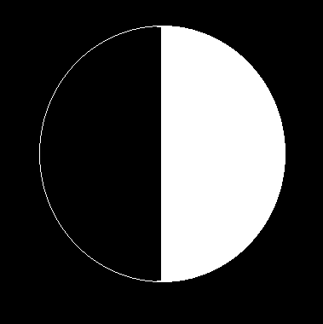
But that’s only a quarter way there.

It’s Waxing Gibbous; that looks like a Full Moon.
(Oh wait there’s a part missing, left side is dark thinning.)
Oooooh

I got a Full Moon for you.
Yeah, go run and tell your little friends.

I see it hanging all around.
In the sky above and I’m like
The Moon
Oo, Oo, Oo
I guess the change in the phases
Brightens it up; I’m like
The Moon.
It’s a Full Moon too.
Is that a Lunar Eclipse, yeah, Earth’s shadow
Casts on it.
Now the Moon ain’t lit (Moon’s dark bit)
And although there’s Waxing and Waning
I still like it best with a
Full Moon.

Now the Full Moon changes tomorrow.
Begins Waning Gibbous so neat.
Trying to keep lit in its orbit.

‘Cause Third Quarter left half gets the heat.

The Waning Crescent looks like a “C” askew.
(Oh wait there’s a part missing, just thought
the right side was hiding)
Ooooh

I’ve got a New Moon for you.
Yeah, go run and tell your little friends.

Scaffolded Moon Phases Paragraph:
(Supporting Detail Sentence One)  For example when the moon is in front of the Earth…. | (Supporting Detail Sentence Two)  Also, when the moon has moved seven days revolution….
(Introductory Sentence)
Although the moon is always lighted on one side….

(Concluding Sentence)
Through the moon’s cycle each phase of the moon…..

(Supporting Detail Sentence Three)  Following the distinct pattern we see the moon’s lighted surface become… | (Supporting Detail Sentence Four)  Finally, after the moon reaches its full moon stage, it…..

____________________________________________________________________________________________________________________________________________________________________________________________________________________________________________________________________________________________________________________________________________________________________________________________________________________________________________________________________________________________________________________________________________________________________________________________________________________________________________________________________________________
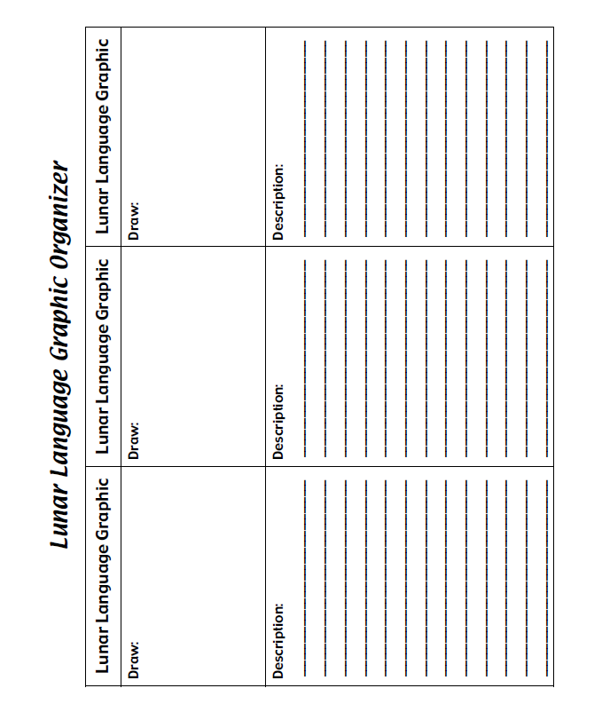
Styrofoam Moon Materials:

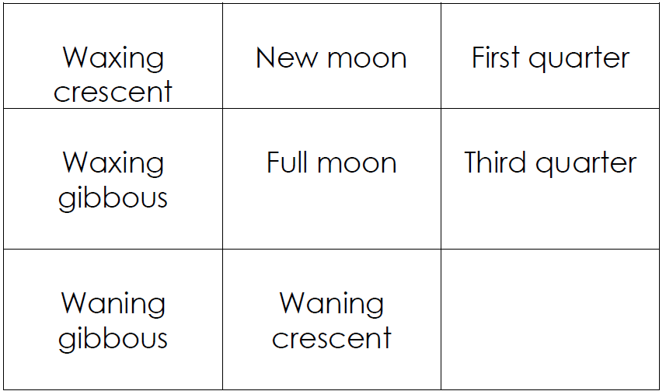
Moon Light Through the Month
Content Standards:
The student will be able to:
- Describe changes in the appearance of the moon during a month.
- Identify the pattern of change (phases) in the moon’s appearance.
Language Standard:
SWBAT
- Write a description of each moon phase to be included on the poster.
- Work with partner, discussing and sharing (speaking and listening) to ideas and suggestions.
- Present poster to the class.

Engage: Show animated diagram: http://www.sumanasinc.com/webcontent/animations/content/moonphase.html
We will be creating a paper copy of this animated diagram.
- Using the Earth and moon circles template, begin by coloring a strip of yellow on the right side of the paper. Label this side as the source of the sun in the model.
- Color the right side of each large moon yellow to represent that one half of the moon is always lit, and one side is always dark.
- Find the moon that appears totally dark from Earth. Label this moon New Moon and fill in the small circle completely black. The small circle is how the moon appears to a person standing on Earth.
- Move one phase in a counterclockwise motion around the Earth and use a ruler to draw a line from the center point of the Earth to the lit portion of the moon facing Earth. This is a very small segment. Label this phase Waxing Crescent and color a small crescent of light on the right side of the small moon with mostly shadow.
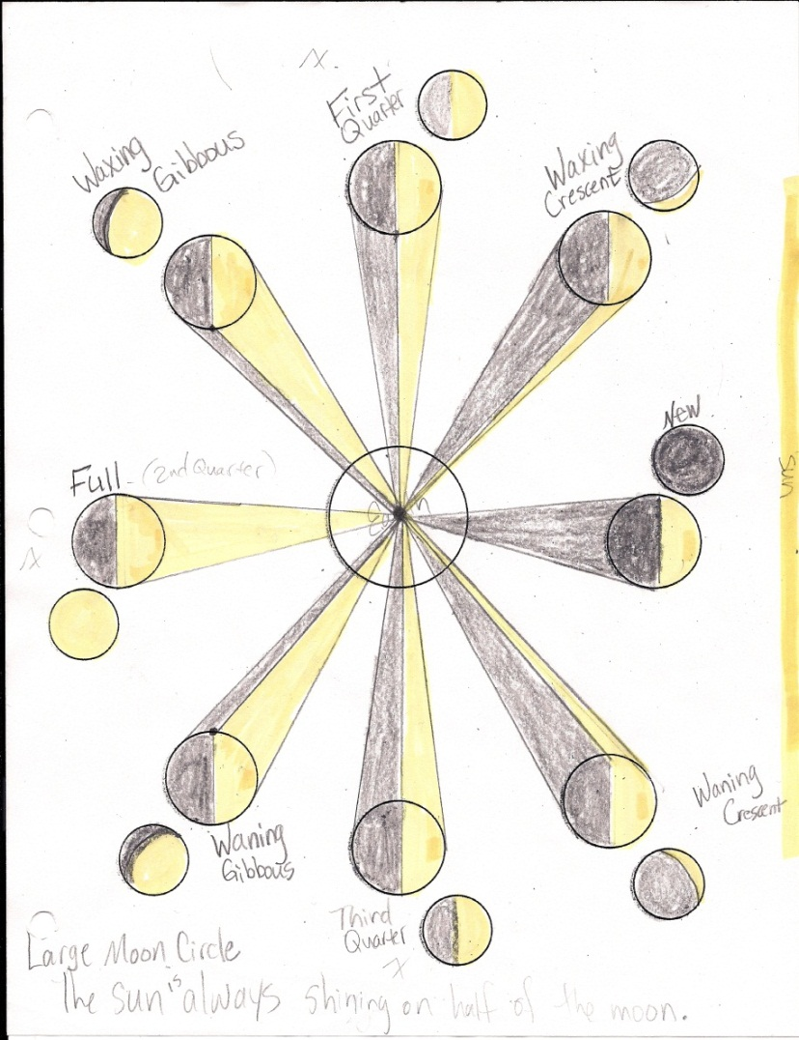
- Continue around to each phase. Draw two lines from Earth’s center to the lit portion of the large moon. Label each phase and color the way the moon appears from Earth.
- Discuss and reinforce the counterclockwise revolution of the moon around Earth. Point out the location of the sun, moon, and Earth in the various phases.
Completed Example:

CONCLUSION:
Review anchor chart—What we knew, what we wanted to know, and what we learned. Answer any lingering questions.
Group Poster Creation:
Materials for Each group: Moon phase phrase cards, poster board, moon phase picture cards, colored markers, glue or tape, art paper for moon, earth, and sun creation.
Give students Moon Phase phrase Cards. Have them arrange them in sequential order on desks for reference when drawing their moon phases on the poster paper.
Go around to each group and observe, taking notes on how they have arranged them.
Monitor the progress of each group until all the groups have finished, and they are satisfied with their charts.
Next distribute Moon Phrase Picture Cards with definitions of each moon phase to ELL students. Have students match pictures with Moon Phase Phrase Cards. Write the description of the moon phase on the poster.
Have students refer to their diagrams from Day Two to check their order.
Add creative touches to the moon, earth, and sun to make the posters visually pleasing. Hang the posters for reference.
Students assess themselves using rubric. Teacher assesses using rubric.

Moon Phases Poster Rubric

Name ______________________________

Date _______________________________

 | Beginning  1 | Developing  2 | Accomplished  3 | Exemplary  4 | Self  Score | Teacher  Score
Moon Phase Illustrations | Less than five of the moon phases were correctly illustrated | At least five of the moon phases were correctly illustrated | Six or seven of the moon phases were correctly illustrated | All moon phases were correctly illustrated
Accurate Labels | Labels are inaccurate | Labels have more than two errors | Labels have one or two errors | Accurate labeling
Spelling, Handwriting | Many spelling errors, illegible, messy | A few errors, almost illegible | Only one or two errors, legible writing | Perfect Spelling, Neat legible writing
Timeliness | Over a week late | A week late | A day or two late | Handed in on time

SIXTH GRADE SCIENCE MOON UNIT CHECKLIST:
Standard 1: Students will understand that the appearance of the moon changes in a predictable cycle as it orbits the Earth and as Earth rotates on its axis.
Objective 1: Explain patterns of changes in the appearance of the moon as it orbits Earth.
- Explain patterns of changes in the appearance of the moon as it orbits Earth.
- I know why the moon looks different on different nights.
- Describe changes in the appearance of the moon during a month.
- I can make a drawing of how the moon will look each night over a month.
- Identify the pattern of change in the moon’s appearance.
- If you show me a picture of the moon, I can make a good guess at what it will look like in two weeks.
- Design an investigation, construct a chart, and collect data depicting the phases of the moon.
- I can design a method of gathering data that will show how the moon changes phases.
Objective 2: Demonstrate how the relative positions of Earth, the moon, and the sun create the appearance of the moon’s phases.
- Identify the difference between the motion of an object rotating on its axis and object revolving in orbit.
- I know the difference between an object that is spinning and an object that is going in big circles.
- Model the movement and relative positions of Earth, the moon, and the sun.
- I can use regular items (like balls) to show how close the Earth, moon, and sun are to each other and how they move.

