Lesson Objective: EE.9 SWBAT write an equation to represent the relationship between an independent and dependent variable.
Essential Question: How can you write an equation to represent the relationship between an independent variable and a dependent variable?
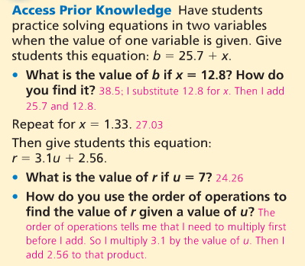
VOCABULARY--WHAT ARE INDEPENDENT AND DEPENDENT VARIABLES?
Question: What's a variable?
Answer: A variable is an object, event, idea, feeling, time period, or any other type of category you are trying to measure. There are two types of variables-independent and dependent.
Question: What's an independent variable?
Answer: An independent variable is exactly what it sounds like. It is a variable that stands alone and isn't changed by the other variables you are trying to measure. For example, someone's age might be an independent variable. Other factors (such as what they eat, how much they go to school, how much television they watch) aren't going to change a person's age. In fact, when you are looking for some kind of relationship between variables you are trying to see if the independent variable causes some kind of change in the other variables, or dependent variables.
Question: What's a dependent variable?
Answer: Just like an independent variable, a dependent variable is exactly what it sounds like. It is something that depends on other factors. For example, a test score could be a dependent variable because it could change depending on several factors such as how much you studied, how much sleep you got the night before you took the test, or even how hungry you were when you took it. Usually when you are looking for a relationship between two things you are trying to find out what makes the dependent variable change the way it does.
Many people have trouble remembering which is the independent variable and which is the dependent variable. An easy way to remember is to insert the names of the two variables you are using in this sentence in they way that makes the most sense. Then you can figure out which is the independent variable and which is the dependent variable:
(Independent variable) causes a change in (Dependent Variable) and it isn't possible that (Dependent Variable) could cause a change in (Independent Variable).
For example:
(Time Spent Studying) causes a change in (Test Score) and it isn't possible that (Test Score) could cause a change in (Time Spent Studying).
We see that "Time Spent Studying" must be the independent variable and "Test Score" must be the dependent variable because the sentence doesn't make sense the other way around.
An independent variable is an "input" variable. It's usually something you can control.
A dependent variable is an "output" variable. It's usually something that you measure.
